**Coding Circle Java (translated from Coding Circle Python by Jason Mangold)**

**Lesson 1**

* A String is any value between quotes (''double quotes") e.g. “Hello Coding Circle”, "I am very smart", "342"
* A char is any single character between quotes (‘single quotes’) e.g. ‘h’, ‘H’, ‘7’, ‘&’
* An integer is any whole number, positive or negative e.g. 145, -3, 5
* A double is any number with a decimal point e.g. 3.14, -2.5
* A boolean is any true or false statement e.g. true, false, 1<2, 1>2

To print a value to the screen, we use the function 'System.out.print()' or ‘System.out.println();’

print->prints things on same line

println->prints things on new line (probably more common)

e.g. System.out.print(1);

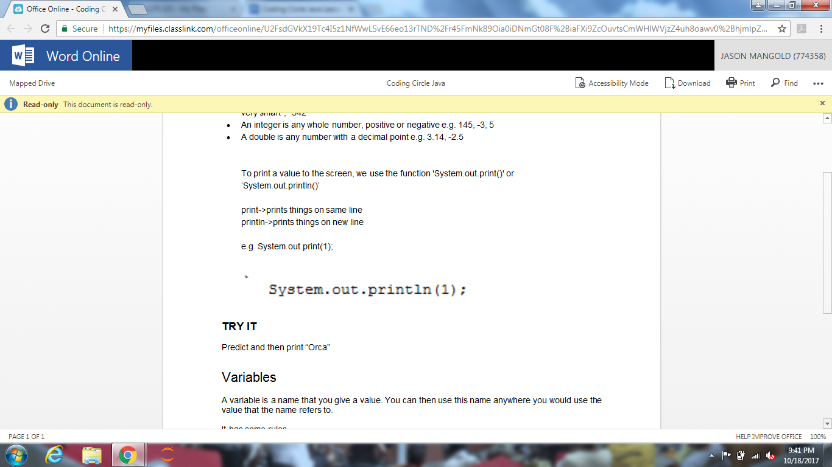

**TRY IT**

Predict and then print “Orca”

Variables

A variable is a name that you give a value. You can then use this name anywhere you would use the value that the name refers to.

It has some rules.

* · It must only contain letters, numbers and/or the underscore character.
* · However, it cannot start with a number.
* · It can start with an underscore but this usually means something special so stick to letters for now.

To assign a value to a variable, you give the variable type, then you use the assignment operator, which is '=' e.g., String my_name = “Jason”;

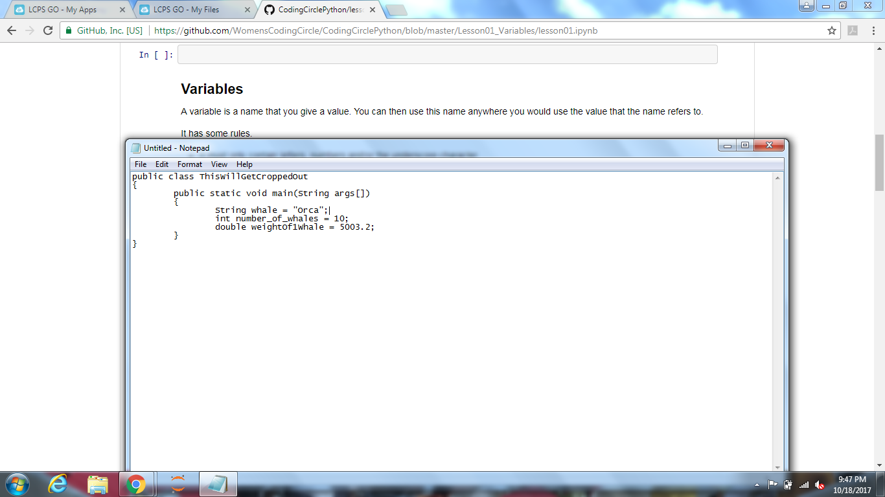

Notice that when you ran that, nothing printed out. To print a variable, you use the same statement you would use to print the value. e.g. System.out.println(whale);

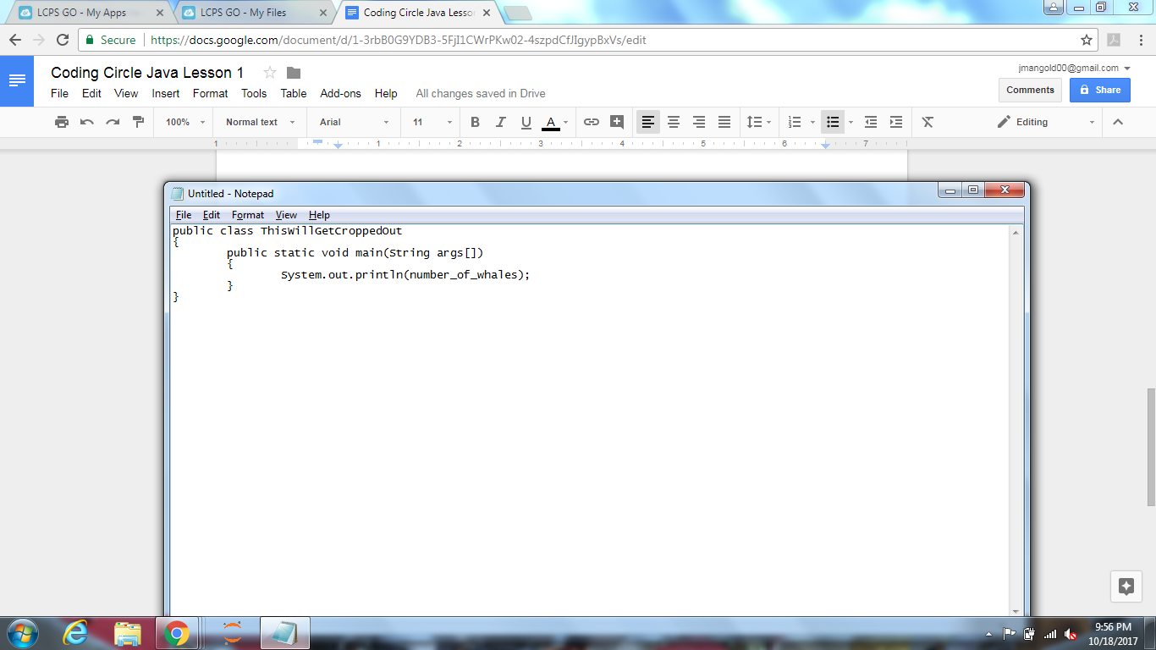

**TRY IT**

Assign the name of a sea creature to the variable seaCreature. Then print the value.

*Recommendation* Name your variables with descriptive names. Naming a variable 'a' is easy to type but won't help you figure out what it is doing when you come back to your code six months later.

Operators and operands

Operators are special symbols that represent computations that the computer performs. We have already learned one operator: the assignment operator '='.

Operands are the values the operator is applied to.

Basic math operators

* + addition
* - subtraction
* * multiplication
* / division

To use these operators, put a value or variable on either side of them. You can even assign the new value to a variable or print it out.

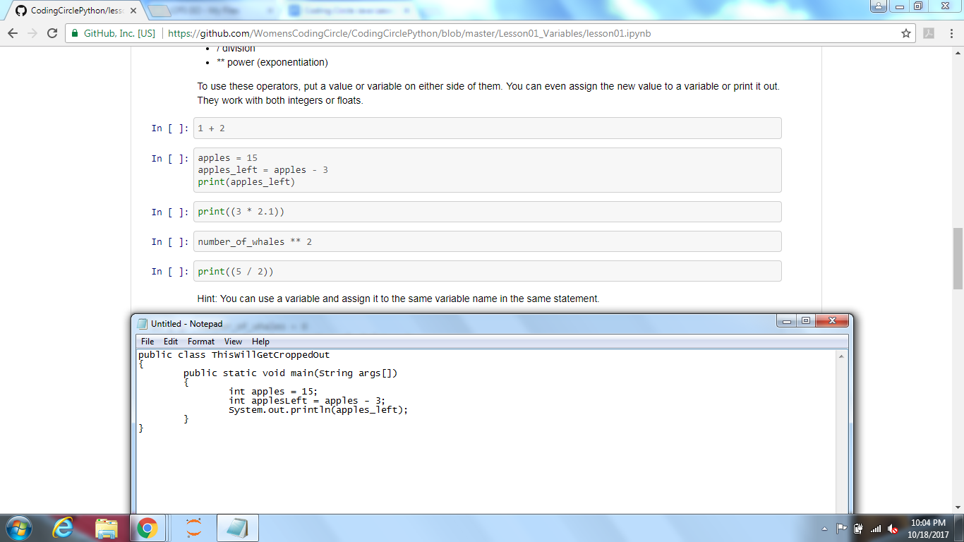

Hint: You can use a variable and assign it to the same variable name in the same statement.

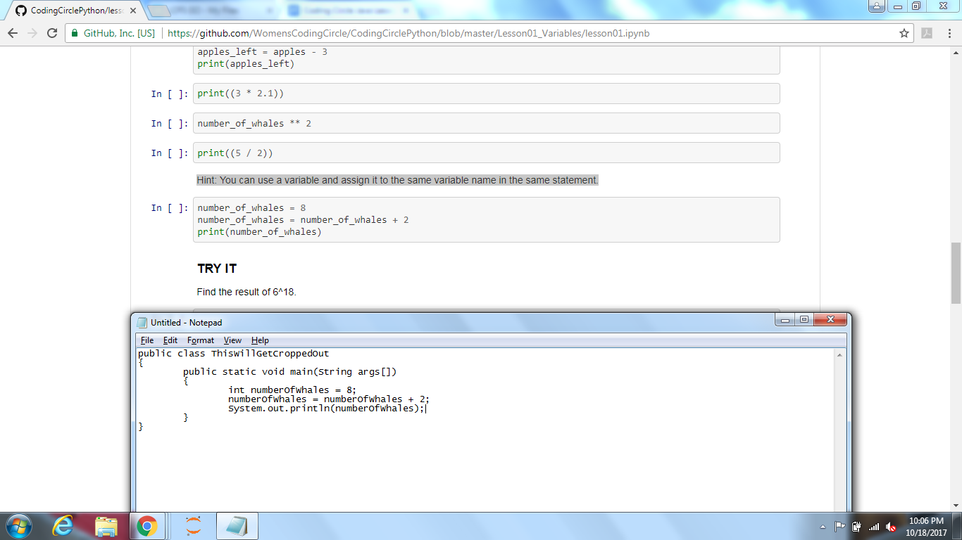

**TRY IT**

Find the result of 6*18.

Order of operations

You can combine many operators in a single Java statement. The way Java evaluates it is the same way you were taught to in elementary school. PEMDAS or Please Excuse My Dear Aunt Sally. Or 1. Parentheses, 2. Exponents, 3. Multiplication, 4. Division, 5. Addition, 6. Subtraction. Left to right, with that precedence. It is good practice to always include parentheses to make your intention clear, even if order of operations is on your side.

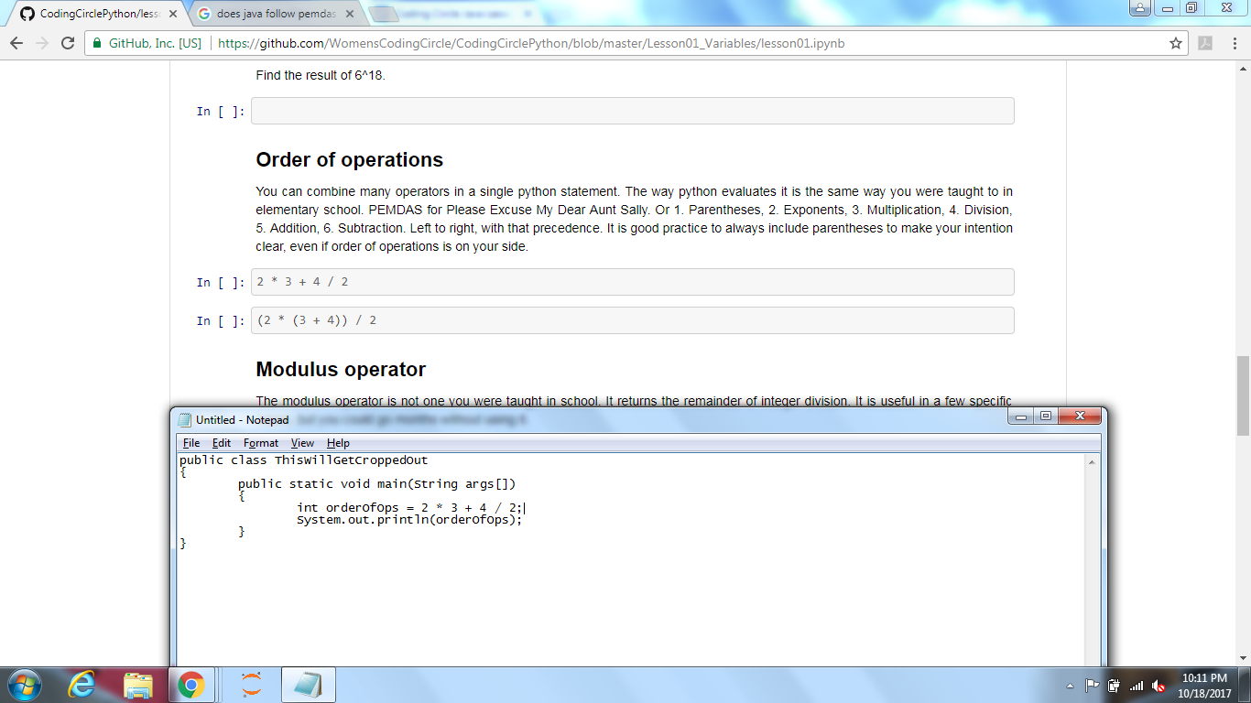

Modulus operator

The modulus operator is not one you were taught in school. It returns the remainder of integer division. It is useful in a few specific cases, but you could go months without using it.

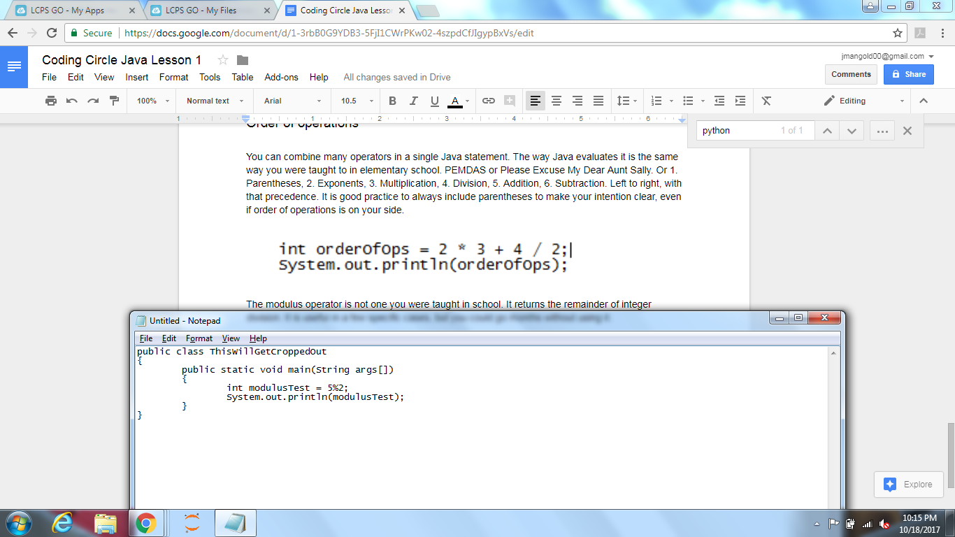

**TRY IT**

Find if 12342872 is divisible by 3

String operations

The + operator also works on strings. It is the concatenation operator. Meaning it joins the two strings together.

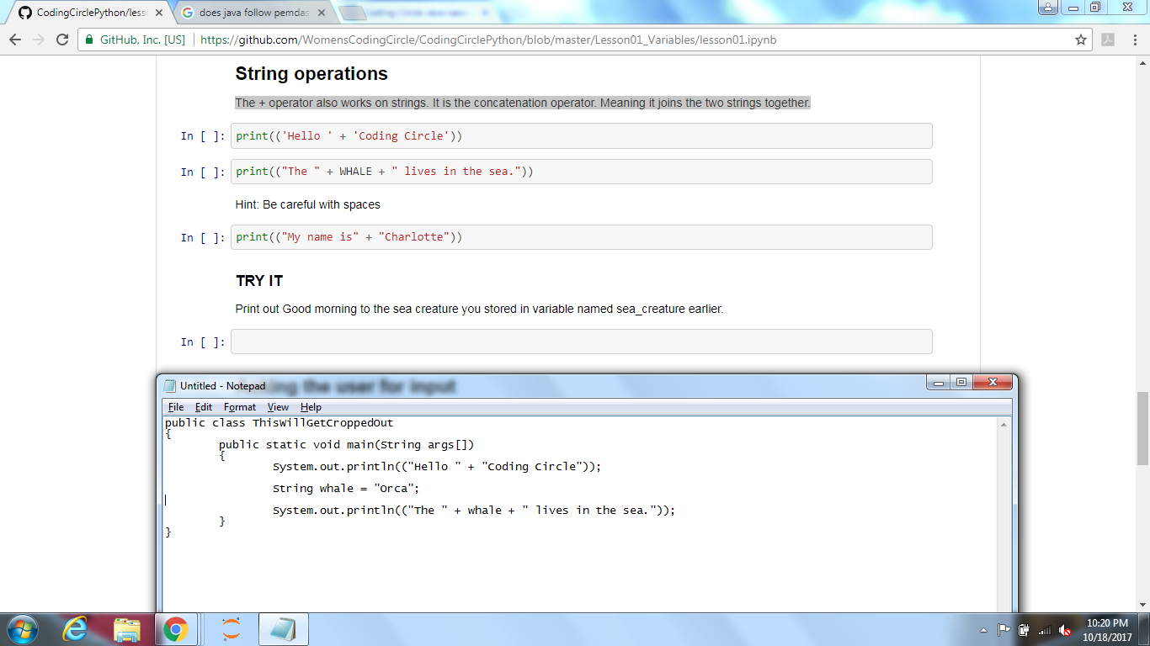

Hint: Be careful with spaces

**TRY IT**

Print out Good morning to the sea creature you stored in variable named sea_creature earlier.

Asking the user for input

To get an input for the user we use the Scanner class.

To import the Scanner class you will need to type--import java.util.Scanner;--at the very top of your code.

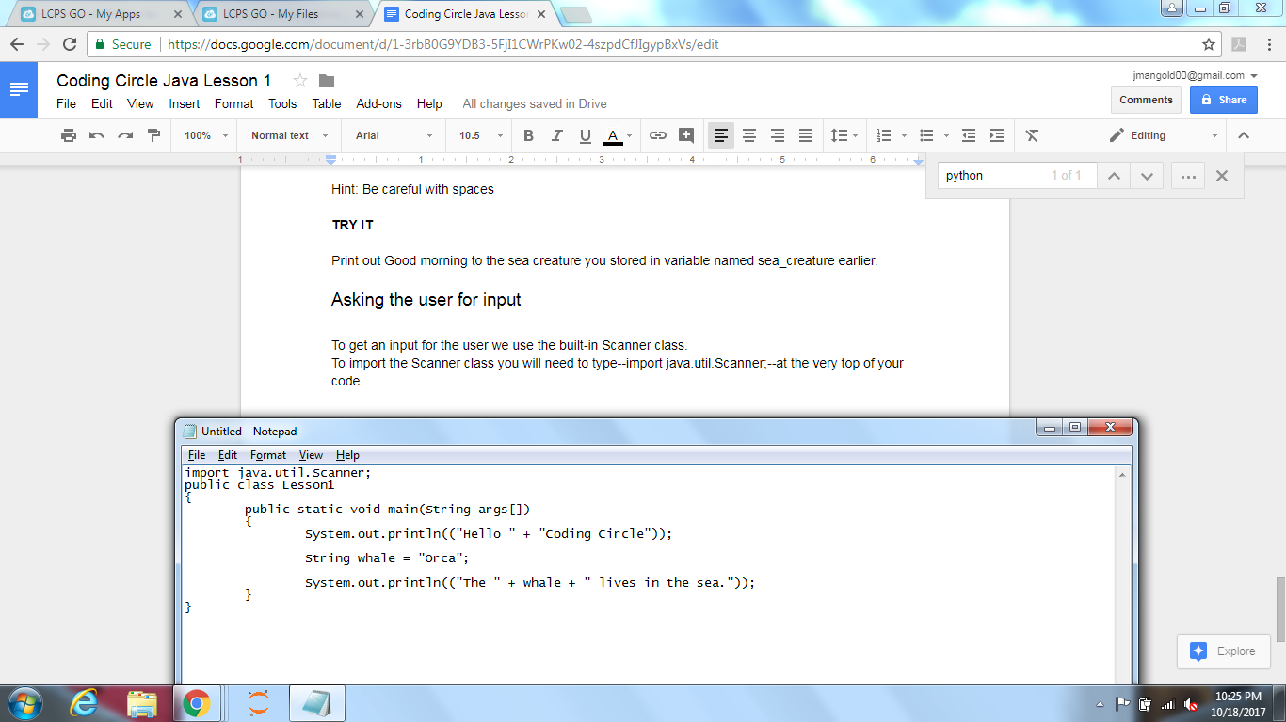

Next, you will need to create a Scanner object by typing--Scanner scan = new Scanner(System.in);-- inside your main function.

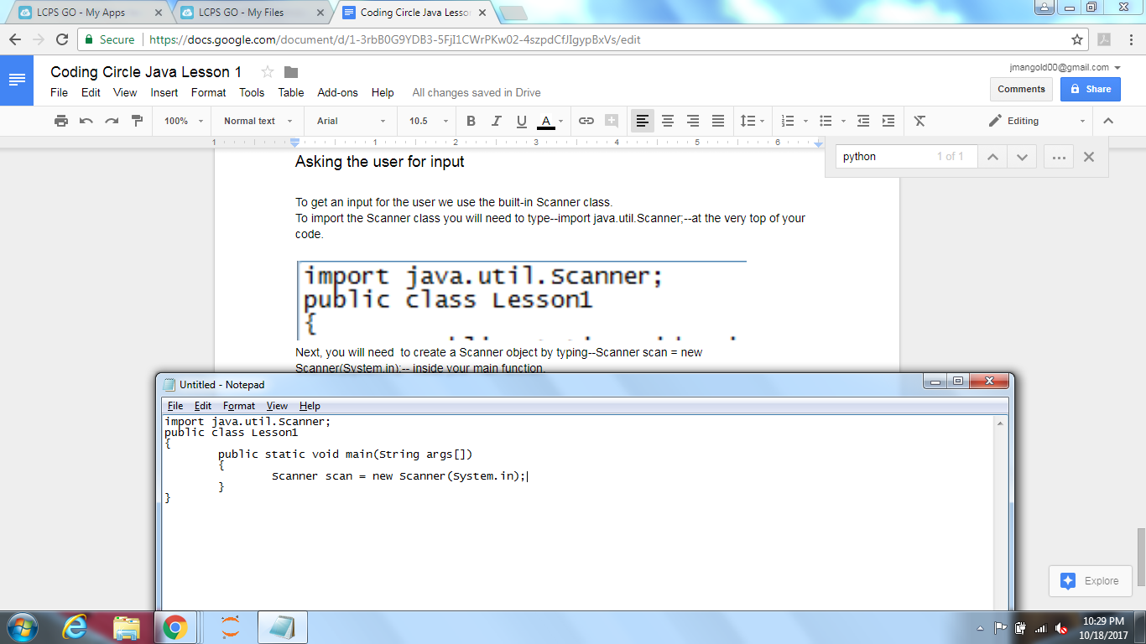

To get an input for the user we use one of the Scanner functions and assign it to a variable.

The Scanner functions that you will mainly be using are:

* next(); -> This takes the first word you type
* nextLine(); -> This takes every word on the line that you type.
* nextInt(); -> This takes the first integer you type.
* nextDouble(); -> This takes the first double you type.

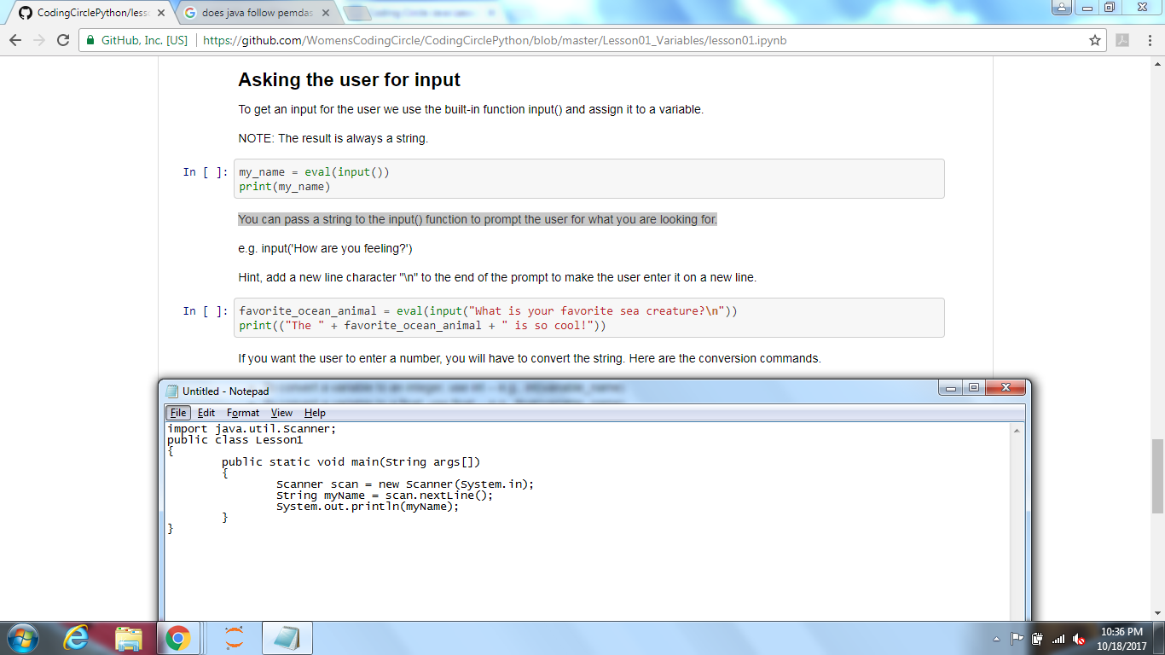

You can print out a prompt before scanning so the user knows what to input.

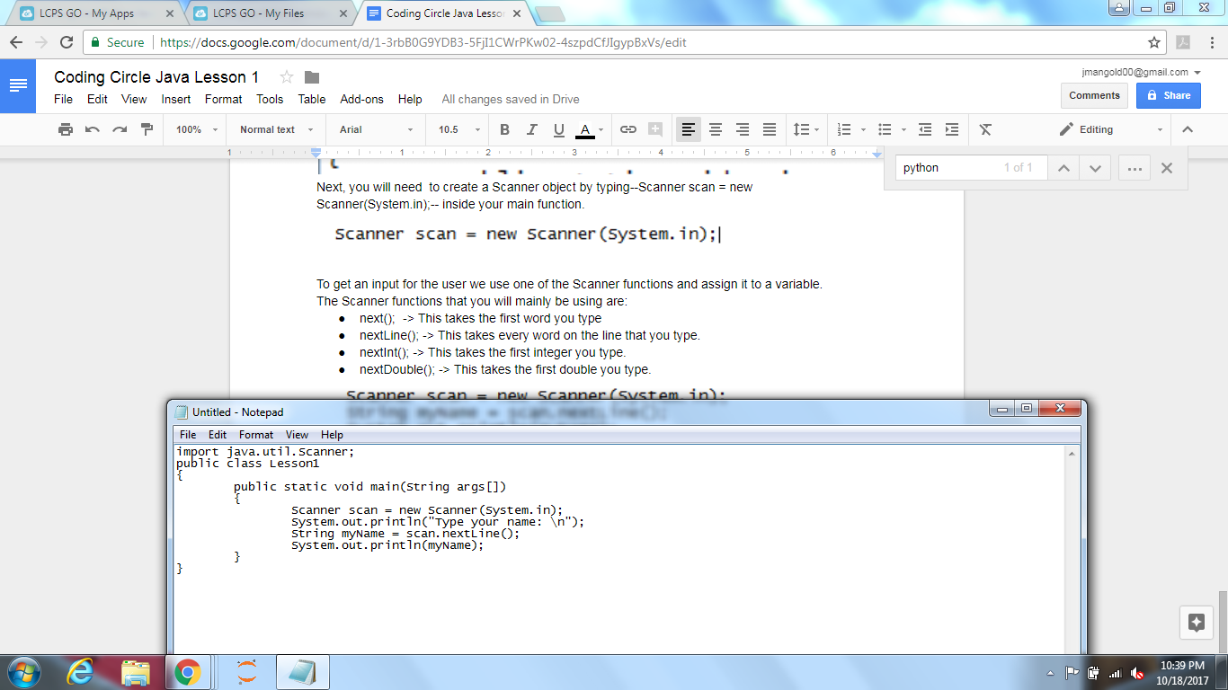

Hint, add a new line character "\n" to the end of the prompt to make the user enter it on a new line.

**TRY IT**

Prompt the user for their favorite color and store the value in a variable called color.

Comments

Comments let you explain your program to someone who is reading your code. Do you know who that person is? It is almost always you in six months. Don't screw over future you. Comment your code.

To make a comment: you use //. You can put a comment on its own line or at the end of a statement.

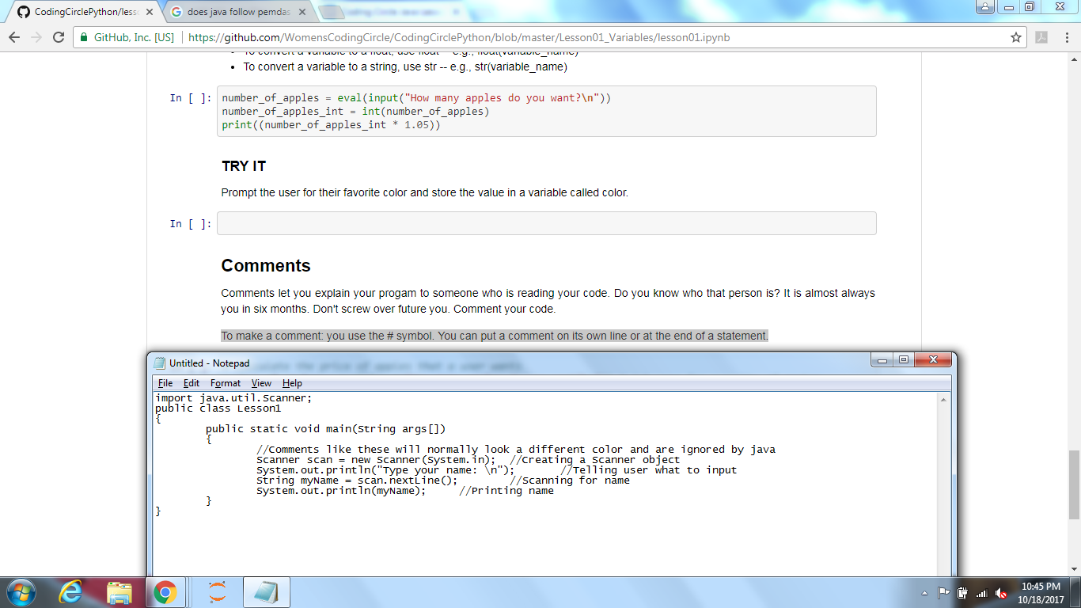

**TRY IT**

Write a comment.

**PROJECT**

We are going to create an application that prompts the user for their (or their child's) birth year and will calculate and tell them the years of their milestones: Drive a car at 16, Drink alcohol at 21, and Run for president at 35.

1. Ask the user for the birth year and store in a variable called birth_year.
2. Add 16 to the birth_year and store in a variable called drive_car_year
3. Add 21 to the birth_year and store in a variable called alcohol_year
4. Add 35 to the birth_year and store in a variable called president_year
5. Print out the message "You can drive a car in: drive_car_year" and similar messages for the other years. Hint: you will need to use string concatenation.